CSE3112: Software Development Lab.
Project Title: Software Requirements Specification (SRS) for Super Market Management System.

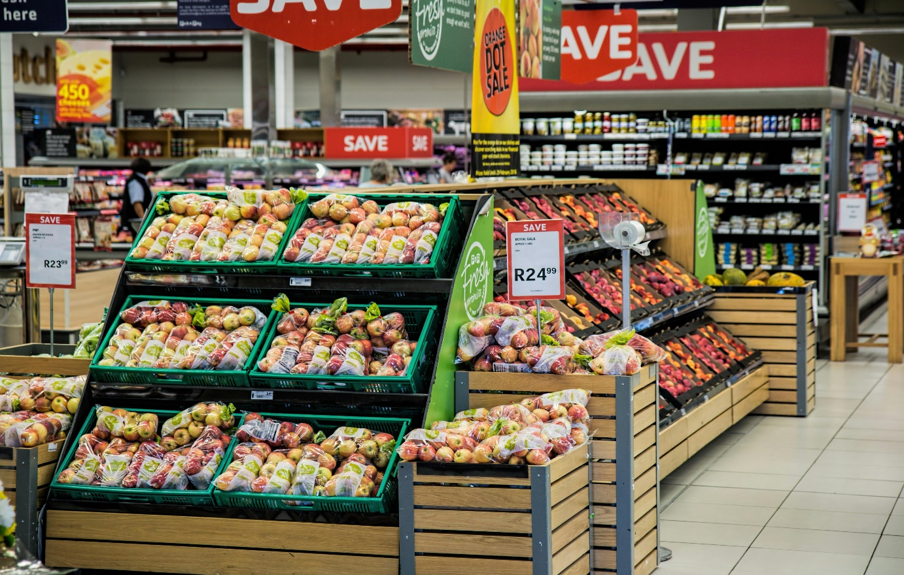
Prepared by,
Name: Syed Maksudul Arafin Dowan.
Roll: 213782101.
Semester: Part-3 (Odd)
Session: 2020-2021.

TMSS Engineering College,
Rangpur Road, Bogura.

